Are the Decathlon Tables Fair?
Richard Crawford
decarcc@gmail.com
Culver City, California, USA
3 June 2018
Copyright Richard Crawford, 2018

Introduction.
The introduction to the 2001 edition of the IAAF Scoring Tables for Combined Events contains a very thorough, interesting, and useful discussion of the principles underlying the 1984 scoring tables for the decathlon and heptathlon which are currently in force. The principles are stated as follows (with some comments by the author in brackets {}):
- The … tables should be used for combined events only.
- Results in various events should … yield about the same number of points if the results are comparable as to quality and difficulty.
- The new tables should be either:
- A modification of existing ones {the 1954 tables for the heptathlon; the 1962 tables for the decathlon};
- A straight line in all events; or
- Slightly progressive tables in all events.
- It must be possible to use the scoring tables for beginners, juniors, and top athletes as well.
- {separate tables for men and women}
- All … tables should be based on the statistical data for the combined events by paying due regard to the statistical data for performances by single event athletes.
- The new tables should be applicable both now and in the future.
- {Try to keep scores of elite athletes about the same as they were with the older tables.}
- As far as possible the new tables must insure that a specialist in one event cannot overcome performances in the other events.
All 17 events, plus several others to allow for indoor competitions and for the women’s decathlon, use an exponential form that can be written as
P = a [ D (M – b) ]^{c}
where P is the number of points awarded, M is the measurement (the units are seconds for running events, centimeters for jumps, and meters for throws). D is a function that both accounts for the desire to reward running events with more points for smaller values and cuts off the points at zero (for track events D equals -1 for M < b and 0 for M > b, and for field events D equals 1 for M > b and 0 for M < b). ‘a’, ‘b’, and ‘c’ are fitting parameters for each event, determined from the statistical database.
The tables accommodate hand-timed results. The rules for rounding are also discussed.
Before “fairness” cam be investigated, it must be defined. For the purposes of this research, the decathlon scoring tables will be determined to be “fair” if the differential points awarded for an improvement from one percentile to another is the same in each event for athletes of comparable ability. It does not need to be the same for all starting percentiles (that is, the point reward for an increase from the 30th percentile to the 40th need not be the same as from the 50th to the 60th). Neither does it have to be the same for different qualities of athlete. For example, if an athlete who functions at the 7,000-point level improves in one event from the 50th percentile to the 60th percentile, he or she should be rewarded with, to make up a number, 50 additional points regardless of the event. But an athlete who functions at the 8,000-point level might be awarded 75 more points for the same improvement, again regardless of the event.

The data.
Without an enormous amount of data—all events, all levels of competition—it would be very difficult to decide whether all nine of these criteria have been met. The research reported here concentrates on the second criterion as applied to the decathlon, which has been restated in the title. A comparable report concerning the heptathlon is a project for the future.
The data set at hand is based on a set collected by the author in the last 18 years. At the date of this report it currently contains 86,012 results, and it continues to grow. The data set is unfiltered, in that anything the author can find (on the internet, in publications, or by any other means) is acceptable as long as the implements and hurdles used meet the international standards for open competition (106 cm hurdles, 7.26 kg shot, 2 kg discus, 800 gm javelin). The starting date is 1 January 1988. The most recent result is from 23 April 2018.
The author thanks Enn Endjärv of decathlon2000.com, who has shared a large amount of data over the years.
For the purposes of the research reported here, the data set was pruned by discarding all results for which
- not all individual event marks are available,
- the reported point total does not equal the total computed from the reported event results (to remove scoring errors and reporting errors); or
- the athlete did not score at least one point in each event (no “no mark” or “did not finish”).
The last criterion also removes some legitimate results in which an athlete performs so poorly in an event that the tables assign zero points to the performance. There are not many such performances removed because of this, and they would affect only the lowest scores – much lower than those discussed here.
Wind and altitude effects have been ignored; they are also ignored by the tables.
These produced a useable data set consisting of 63,576 decathlon results, ranging from Ashton Eaton’s 9045 (Beijing, People’s Republic of China, 29 August 2015) to Christoph Ziniel’s 1329 (Vienna, Austria, 25 May 2008).

Data Processing
The data set was partitioned into bins of 250 points in an attempt to group together athletes of “comparable ability”. In practice, this simply means that all performances that fall into a given range are grouped together. If two athletes score 7500 points, there is no way to determine that one of them is an 8500-point quality athlete having a sub-normal day and the other a 6500-point athlete having the meet of his life. Nor does it make any sense to group Ashton Eaton’s first decathlon (6977, Tucson, Arizona, 23 March 2007, which ended in torrential rain) with his world record eight years later; his abilities clearly improved during that interval.
This scheme works directly with the points awarded; there is no need to deal with the actual marks in each event.

Medians
First, the medians for each event are considered for each point group. These are displayed in Figure 1. The data themselves are presented in Table 1. In the table, “Number” is the number of results in the point range, “mean” is the mean value of the point total for the results in the range, and “Σ(Medians)” is the sum of the individual event medians. The “8250 +” range is used instead of the 8500-8749 point range simply because there would have been too few points to give a reasonable estimation of the distribution function for each event (the 8500-8749 range contains only 157 results).

Table 1. Medians for each event for each point range.
Range | 4000-4249 | 4500-4749 | 5000-5249 | 5500-5749 | 6000-6249 | 6500-6749 | 7000-7249 | 7500-7749 | 8000-8249 | 8250 +
Number | 1320 | 1985 | 2960 | 3655 | 4461 | 4386 | 5540 | 3468 | 1206 | 651
Mean | 4098 | 4611 | 5112 | 5619 | 6116 | 6618 | 7137 | 7610 | 8099 | 8437
Σ(Medians) | 4073 | 4594 | 5113 | 5622 | 6124 | 6630 | 7114 | 7630 | 8102 | 8439
100m | 551 | 606 | 651 | 691 | 723 | 757 | 789 | 825 | 856 | 897
Long Jump | 453 | 508 | 556 | 608 | 661 | 720 | 778 | 835 | 888 | 942
Shot Put | 409 | 437 | 469 | 505 | 548 | 599 | 649 | 707 | 758 | 790
High Jump | 449 | 496 | 544 | 585 | 636 | 679 | 723 | 767 | 803 | 840
400m | 478 | 542 | 596 | 650 | 695 | 735 | 773 | 811 | 849 | 882
110mH | 323 | 428 | 542 | 631 | 695 | 758 | 808 | 857 | 905 | 940
Discus | 343 | 371 | 414 | 459 | 513 | 568 | 627 | 691 | 747 | 784
Pole Vault | 275 | 342 | 406 | 482 | 562 | 645 | 702 | 790 | 849 | 880
Javelin | 346 | 381 | 417 | 454 | 502 | 556 | 618 | 675 | 739 | 776
1500m | 446 | 483 | 518 | 557 | 589 | 613 | 647 | 672 | 708 | 708

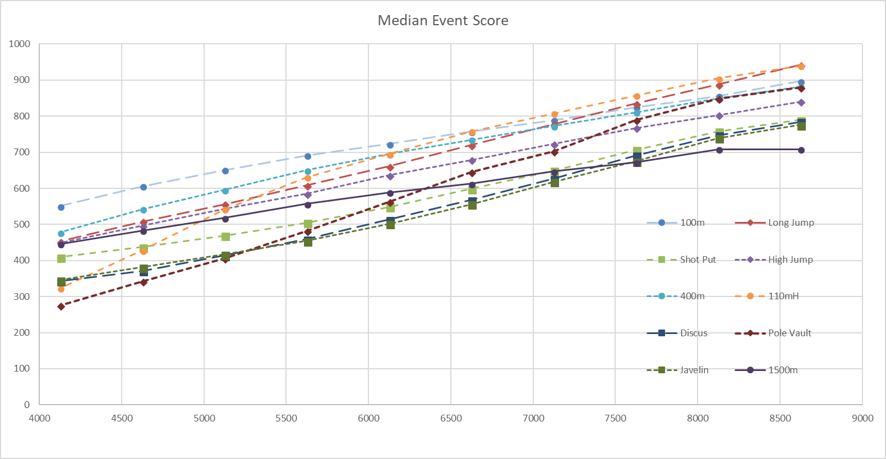

Figure 1. Medians for each event for each point range.

There are a few features of Figure 1 that invite speculation. The two event medians that seem to increase more than the rest are the 110mH and the pole vault. The hurdles median grows fastest through the 4000s, but by 6000 its growth has slowed to be similar to the rest of the events. The pole vault median continues to grow faster than the other events until the top ranges. The throws grow more slowly at lower levels but catch up with the others by 6000 points.
The pole vault median also appears to be less smooth than the others. It seems to have a slight depression at 7100, and another slight depression at 8600. These are artifacts of the way that the medians are computed, combined with the way that most pole vault competitions are conducted. Figure 2 shows the distribution function (fraction of samples below a given value) for the pole vault in the 8250 + point range. Note the vertical steps. These occur quite regularly—every 15 points or so. This is due to the preference of the officials to begin a pole vault competition at an even decimeter height (3.00m, 3.50m, etc.) and then proceed in 10-centimeter increments. The huge step at 910 is because in this point range almost 20% of the results had a pole vault mark of 5.00m, which garners 910 points. The smaller rise at 880 points is the 10% of the results with a mark of 4.90m. There is a little step in between that shows a few 4.95m marks (895 points).
The median is found by the simple method of sorting the marks in ascending order, and then locating the middle value in the list. For the two data sets in question, the median of the entire set occurs at the “high end” (the end of the list of pole vault marks of equal value nearer the next higher mark) of the 4.90m set, so the median points value is 880. If a smooth line were drawn through the data, the median (the 0.50 crossing) would occur quite near the 895-point mark (the 4.95m step. Were this “better” value used, the right-most point for the pole vault median would fall almost on top of the 100m median point directly above it.
The slight depression at 7100 points in Figure 1 has a similar explanation—the same, actually, except for the numbers; see Figure 3.
This preference for pole vault heights that are multiples of 10cm does not seem to be the case in the point ranges below 6500. Whether this actually the case or an artifact of the data set cannot be determined from the data set itself. Most of the non-10cm-starting heights are in American meets, which also dominate the lower point ranges.
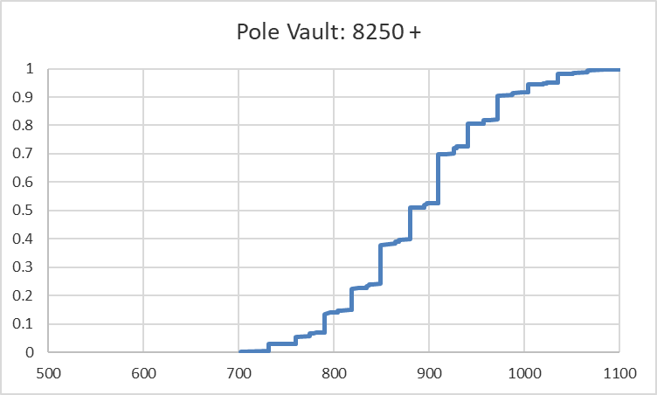
Figure 2. Distribution function of pole vault scores for results above 8250 points.
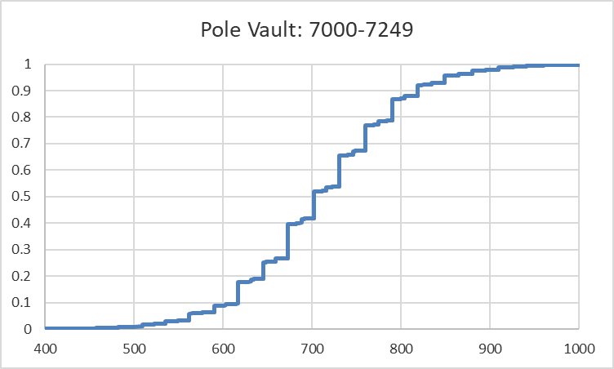
Figure 3. Distribution function of pole vault scores for results between 7000 and 7249 points.

The 1500m median, on the other hand, grows more slowly than any other one across the entire point range. Perhaps this is due to less attention paid to the 1500m in training. But the curve goes absolutely flat at the high end—the median for both the 8000-8249 and 8250 + ranges is 708. Perhaps this is an end-of-the competition effect at major meetings: If you have no chance of running fast enough to get onto the podium or if you have such a lead that you almost can’t miss the podium, perhaps you aren’t motivated to run as quickly as you would if you were in a tight contest for a top three finish (or you were chasing a world record, such as was Ashton Eaton at the Olympic Trials in Eugene in 2012).
It is also obvious that the throws are undervalued compared to the jumps and running events (other than the 1500m). The discus and javelin medians are almost identical in all point ranges; the shot is slightly higher in the low ranges but gets closer to them as the points increase. But the three are always at or near the bottom.
Perhaps these trends reflect emphases in training, particularly for athletes at the lower levels.
It has been widely recognized for many years that the throws do not garner as many points as the other events (always excluding the 1500m). One way to correct this disparity would be to adjust the constants in the equations for the throws, perhaps by increasing ‘b’ or ‘c’. But then the tables might be too progressive, and the equations for other events might need adjustment in response.
But it is not obvious to this author that lower medians are a problem, anyway. Consider the following: Suppose the table for each event was rewritten as a median value plus a differential term dependent upon how far a given mark is from the median mark. Then the total for a decathlon performance would be the sum of the ten medians (which would be a constant) plus the sum of the ten differential terms. When constructing the tables, the medians for each event could be assigned values almost at will, subject only to the condition that their sum be kept constant, and the scores would not change. This scheme is equivalent to assigning each athlete a fixed value at the start of the competition, and then adjusting his score by adding the differential term after each event.
This would, of course, would require an adjustment if there were a zero in an event, perhaps by subtracting one tenth of the starting value.
It would also have an effect if the tables were used to compare results in different events not contested by decathletes. At present, throwers and middle-distance runners have their results undervalued compared to sprinters and hurdlers. [Interestingly, the two decathlon events whose open-competition world records would be awarded the highest point are the discus and javelin, which have among the lowest decathlon medians.] But, by the first guiding principle, the tables aren’t supposed to be used for such purposes anyway.

Fairness
Now consider the event distributions for each of the point ranges.
Figures 4 through 13 show the normalized (in the sense that the median has been subtracted from the actual point values) distribution functions for each event for each point range. These figures directly address the fairness (according to the definition used in this report) question. Note that in Figure 4 the median for the pole vault has been adjusted from 880 to 894 to account for the 10-cm discretization effect discussed above. Similarly, it has been adjusted from 849 to 852 in Figure 5, and from 702 to 710 in Figure 7.
Read the figures in the following way: As an athlete’s position on the vertical axis changes (as the athlete improves from one percentile to another), his score changes by the corresponding amount on the horizontal axis.
In the discussions that follow, the phrase “over-rewarded” will be used to include both cases: an above-median mark will be rewarded with too many points (compared to the other events) and a below-median mark will be rewarded with comparatively too few points. In other words, the curve is too flat. “under-rewarded” will likewise refer to both of the opposite circumstances (the curve is too steep).
If all ten curves were identical in the figure for a particular point range, then the tables would have been completely fair: the improvement from the median to, say, the 60th percentile in each event would have been rewarded with the same number of points. Alas, this idyllic situation is not the case in any point range. Figure 4 shows that, in the 8250 + range, the 400m and 110m hurdles are under-rewarded whereas the javelin is over-rewarded somewhat. But note that the effects are not necessarily symmetric: the hurdles are over-rewarded for above-median marks but not so much for below-median marks, and the opposite is the case for the pole vault.
In the 8000-8249 point range (Figure 5), the 400m and the hurdles are under-rewarded as at the higher level (joined by the 100m below the median), and the 1500m joins the over-rewarded group.
As the point level decreases, the pole vault and 1500m remain over-rewarded, the 100m, shot put, and long jump join the under-rewarded group, and the hurdles switch camps, moving from under-rewarded to over-rewarded.

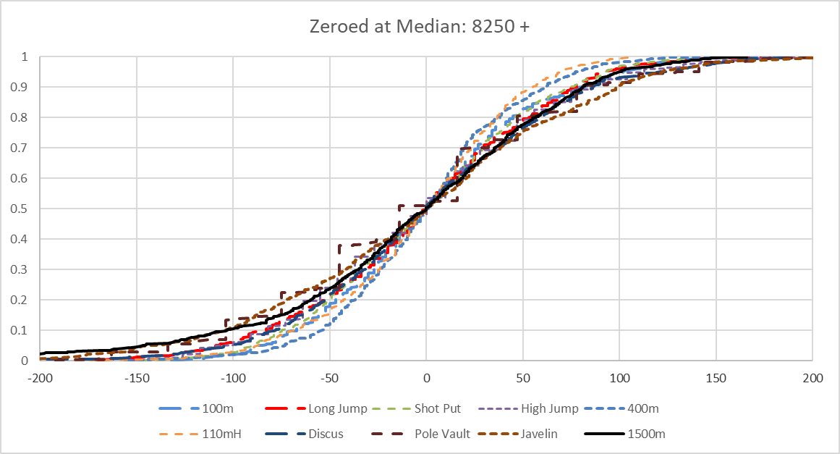
Figure 4. Distribution of Normalized Points for Each Event for the 8250 + Point Range
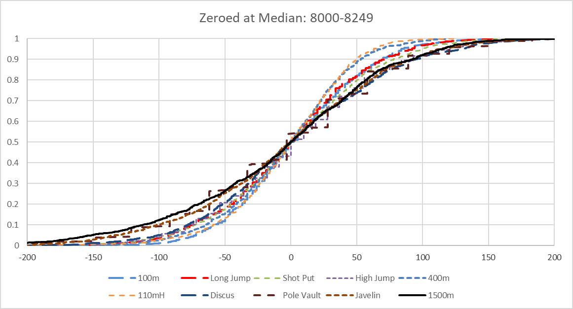
Figure 5. Distribution of Normalized Points for Each Event for the 8000-8249 Point Range

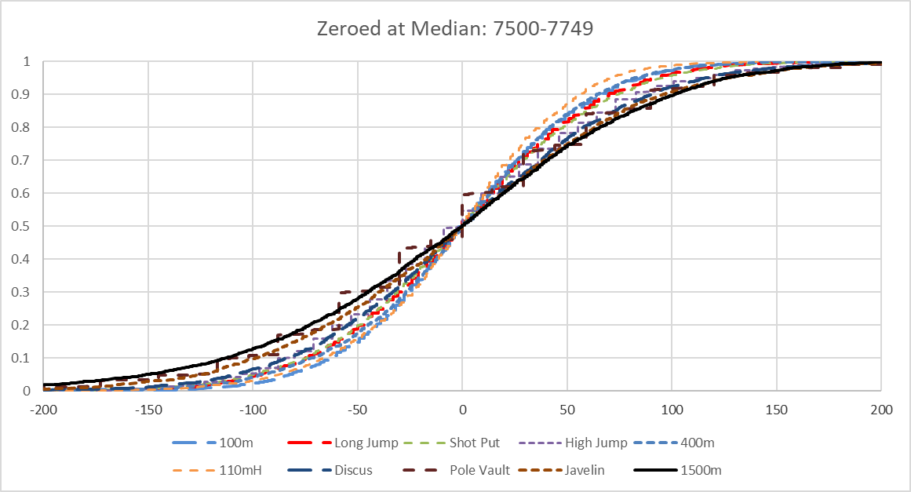
Figure 6. Distribution of Normalized Points for Each Event for the 7500-7749 Point Range
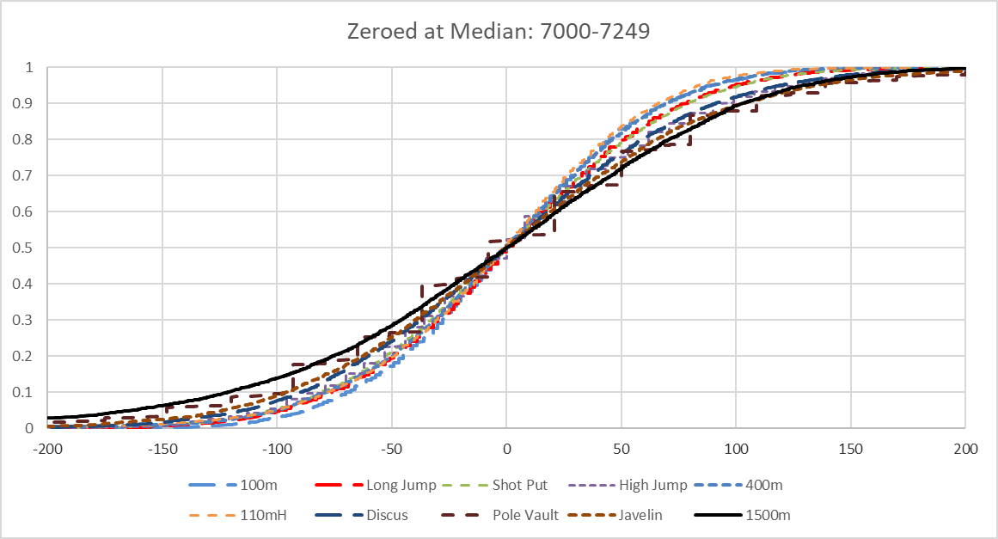
Figure 7. Distribution of Normalized Points for Each Event for the 7000-7249 Point Range

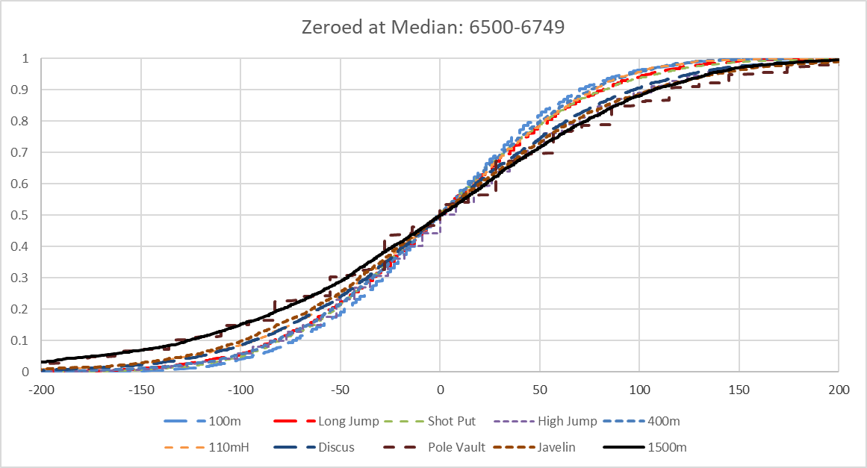
Figure 8. Distribution of Normalized Points for Each Event for the 6500-6749 Point Range
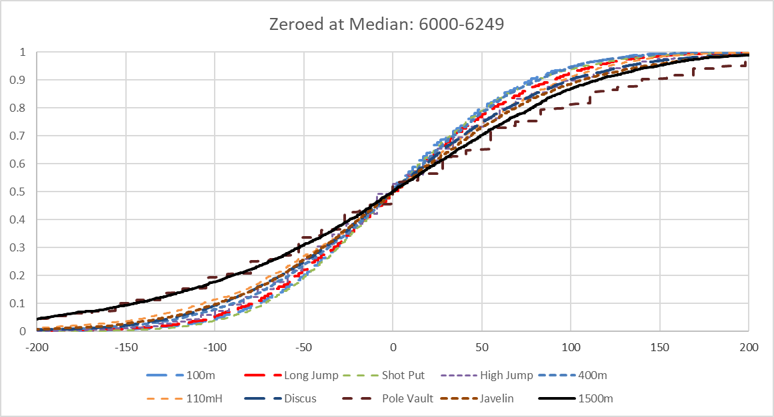
Figure 9. Distribution of Normalized Points for Each Event for the 6000-6249 Point Range

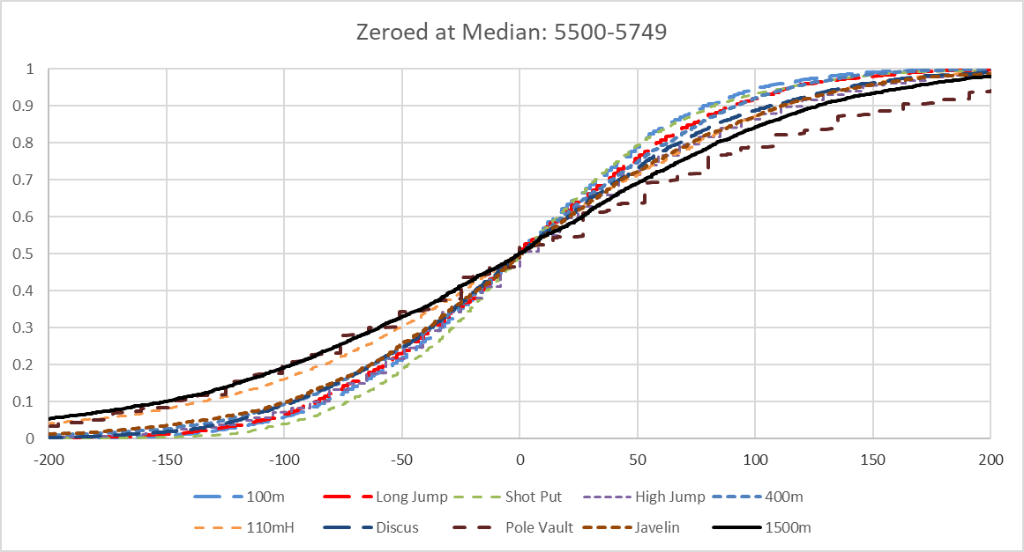
Figure 10. Distribution of Normalized Points for Each Event for the 5500-5749 Point Range
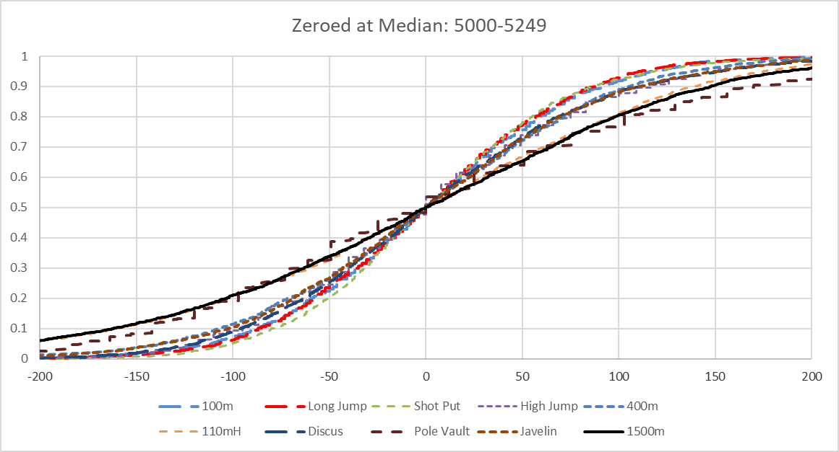
Figure 11. Distribution of Normalized Points for Each Event for the 5000-5249 Point Range

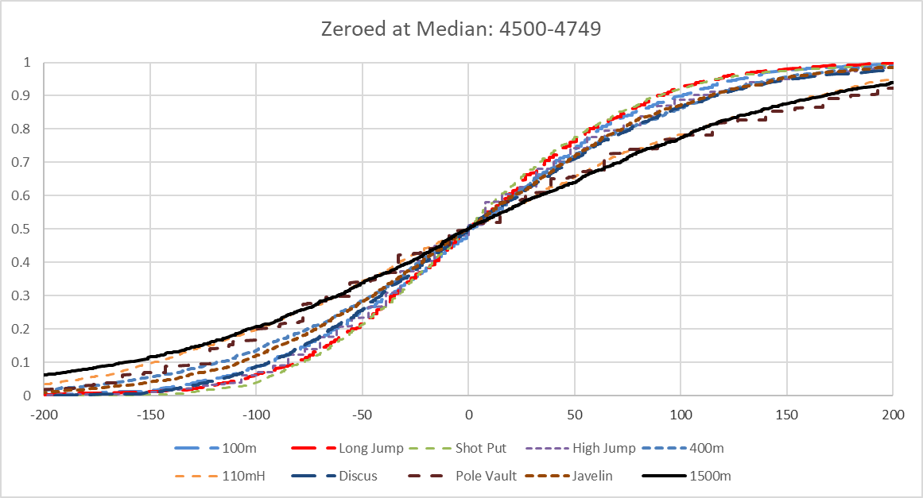
Figure 12. Distribution of Normalized Points for Each Event for the 4500-4749 Point Range
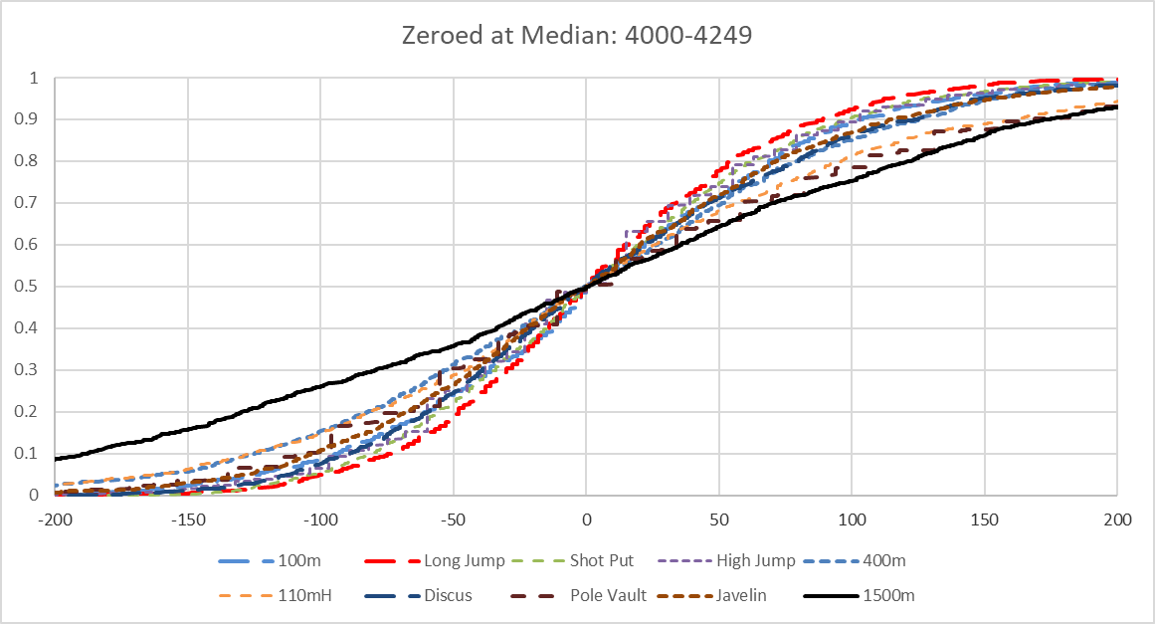
Figure 13. Distribution of Normalized Points for Each Event for the 4000-4249 Point Range

Given the variability of the individual events from point range to point range, it is not clear what the fine structure of these data indicates. A few broad conclusions can be reached, however: The 1500m and pole vault are over-rewarded in most point ranges. In the higher ranges (7000 or more points) the 400m and hurdles are under-rewarded. The tables appear to be fairest in the 6500-8000 ranges.
And, contrary to common knowledge, the discus and javelin are at least as fair as any other event, and fairer than several; they are in the middle of the distributions for most point levels.

